

PROPOSAL/CONTRACT FAST DRYING
TENNIS COURT RECONDITIONING
PASEO FORT MYERS

Ritzman Courts, as Contractor, offers to recondition (6) Har-Tru Hydrocourt tennis courts for Paseo Fort Myers, as Owner, according to the following terms and specifications.

SCOPE

The (6) court surfaces shall be thoroughly cleaned and prepared in such a manner as to provide a good bond with the new surface material applied. The entire surface shall be scarified. Mold and algae growth shall be aggressively worked by hand and with machine pulled implements, gathered and removed from the courts.

The new surface shall be applied at a rate of (18) tons total, (3) tons per court. The new surface material lift shall be applied using a continuous moving straight edge to bring the court to a truer plane with less low areas for overall better storm water drainage and playing conditions.

After the proper compaction is achieved, new line tape shall be positioned exactly to USTA specifications.

SPECIFICATIONS

All work shall be completed to the American Sports Builders Association standards for reconditioning fast drying tennis courts. The Contractor shall guarantee the completed work for (1) year.

The Contractor shall furnish all supplies and equipment for work specified.

The Contractor shall remove all job-related waste materials.

The Owner shall provide an area to store all job-related materials and equipment.

The Owner shall provide adequate access to the job site.

The Owner shall also provide an adequate supply of water for irrigation of new surface material.

Price:
The Owner agrees to pay the contract price of twenty seven thousand six hundred dollars, ($27,600.00) due upon completion. Please initial to accept_______.

Upon acceptance and returned to us, this proposal becomes our entire contract.

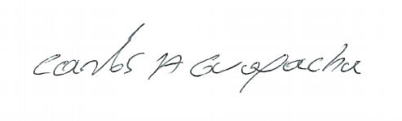
ACCEPTED: RITZMAN COURTS, LLC

Signature: _________________________

By: _______________________________ Carlos A Guapacha

Title: _____________________________ President/Owner

Date: _____________________________ July 29, 2024

E-mail: ___________________________ sales@ritzmancourtsllc.com

1215 SW 7 TH CT • Cape Coral, Florida 33991 • 239-770-2081

